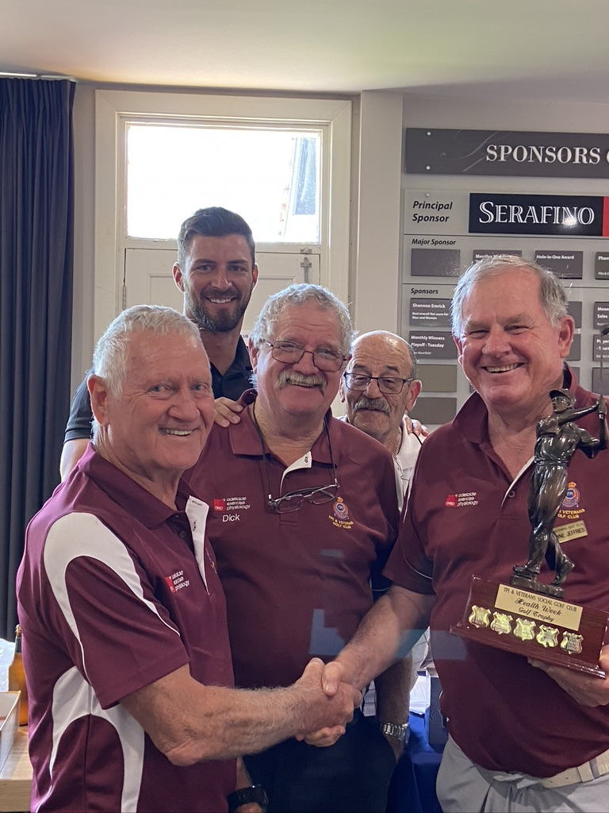
TPI & VETERANS GOLF CLUB REPORT
By Kevin Simper

The annual veterans health week game played at North
Adelaide 21st October was very well attended by veterans
and friends with a field of 36 players the weather and the
company of those people made for a perfect day and I
thank all those who participated.

Winners of the Mike Dennis MBE trophy after handicap
deductions a score of 60.675 from right Wayne Jefferies
Brian Whaites Dick Searl Luke Lorraine with my group
Peter Murphy Gerry Jonek & Peter Shanahan a not very
close runners up.

Winners of the non veterans TJ Wicker Colin Kretchsmer
George Kelly Graham Bowol 61.86 points

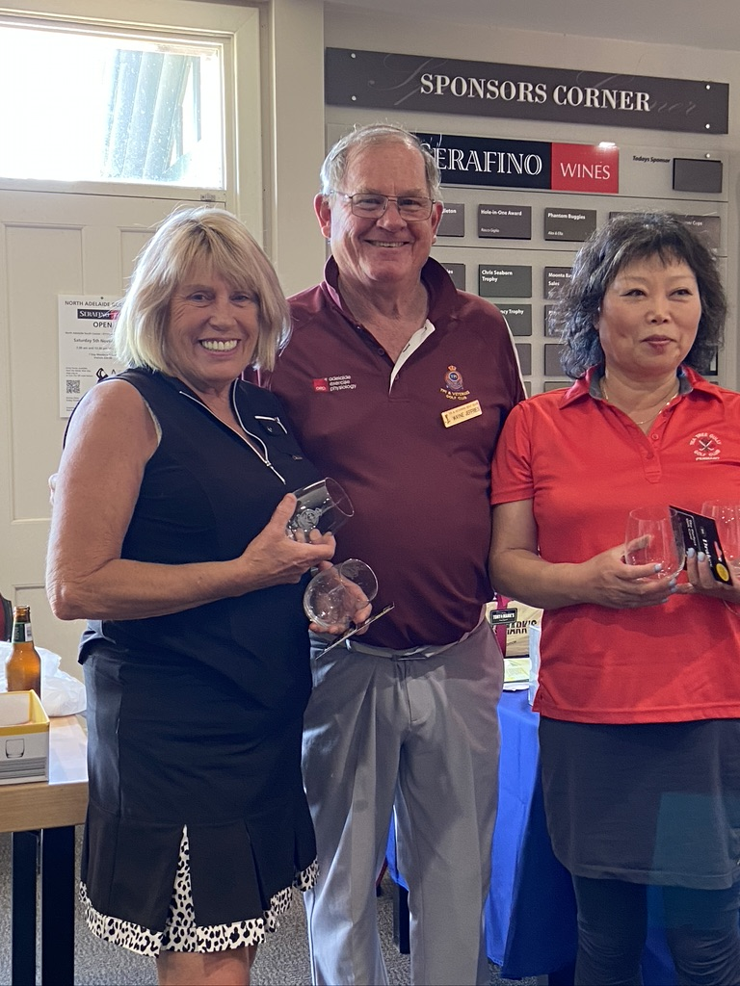
This year we had four lady players and I sincerely thank
Glenda Caroline Moniquie and Carolyn as the club has
trouble attracting ladies to our game.
As there were only four unfortunately I had to play them
against each other the winners by a narrow margin being
Carolyn McDougall and Moniquie Choi trophy presented
by our club secretary Wayne Jefferies

At this time we also do our club champion decided by the
total of the best five games of the year and won by Eric
Sazflic as you can see there was a bit of fun there is only
one club champion jacket and dose not fit everybody.
Eric also won the best stableford score for the year 42
Stableford points.

The club AGM will be held 6Th December after our game
at North Adelaide The present committee will stand
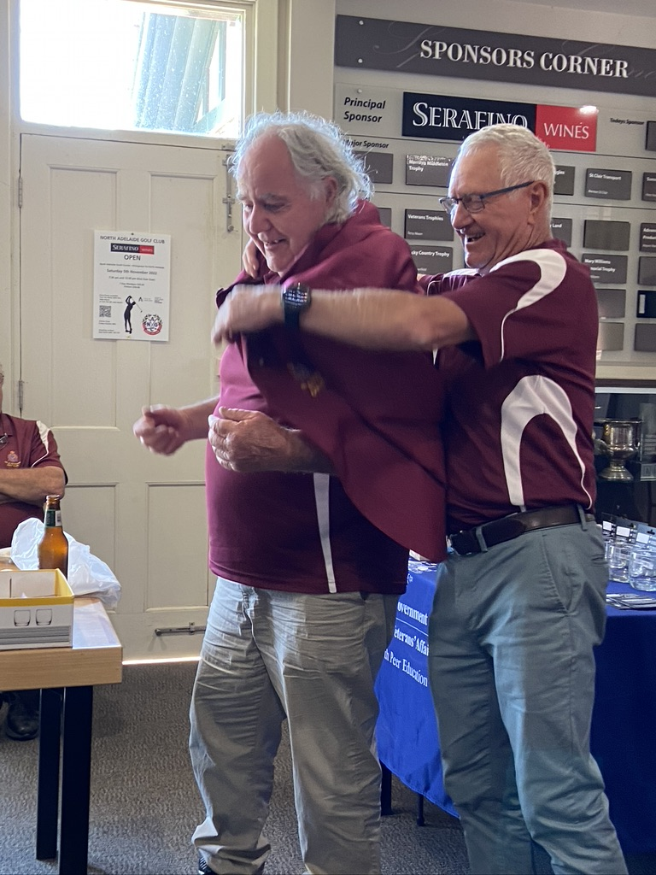
down and hoping all will nominate to continue.
My thanks to Gerry Jonek vice president Wayne Jefferies
secretary Dick Searl captain committee members Peter
Mchugh TJ Wicker
Yet to do a 2023 program but our January game will be
Adelaide Shores

In closing I thank our sponsors
TPI Association
Department Veteran Affairs
Adelaide Exercise Physiology
Tony & Marks Fruit
Distinctive Funerals
Allin Towbars
Wishing all veterans family and friends a safe and happy
Christmas and very prosperous 2023
Kevin Simper (President) Ph 0423524884

